SCHOLARSHIP APPLICATION

Please
attach
your child’s
photo
here.
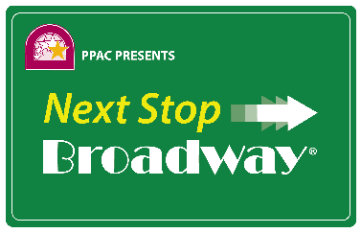
August 6 – 10, 2018
at
Providence Performing Arts Center
220 Weybosset Street, Providence, RI
Application Deadline is March 30, 2018

Parents:
Please fill out this form and send it along with the attached info sheet to Cynthia Goldsmith, Providence Performing Arts Center, 220 Weybosset Street, Providence, RI 02903.

Child’s Name _______________________________ Age as of 8/1/18________ Male___ Female __
Address__________________________________________________________________________
City _______________________ State ____ Zip______ Home Telephone (____)___________
Parent/Guardian Name ______________________________________________________________
Parent Cell phone (____)_________________ Alternate or Office Phone (____)_________________
Parent E-mail __________________________ Child E-mail________________________________
Child’s School _____________________________________________ 2018-2019 Grade _________
Child’s Nickname (if any) ____________________________________________________________
What other scholarships or tuition supplement have you applied for and/or received this year?
_____________________________________________________________________________
While financial need will not be the sole determining factor, it is the goal of the Committee to award scholarships to students interested in the performing arts who would not otherwise be able to attend Next Stop BROADWAY®. This information will be held in the strictest confidence and only shared with the Scholarship Selection Committee.

Our family’s annual income is:
$0-$20,000 $20,000-$40,000 $40,000-$60,000 $60,000- $80,000 $100,000+

There are ______ children in our household supported on this income.

Optional: please describe any other circumstances that might affect the family’s ability to afford this program (such as number of family members, medical expenses, etc.)

__________________________________________________________________________________________

__________________________________________________________________________________________

__________________________________________________________________________________________

Signature ______________________________________________ Date __________________

For Applicants:

Your Name

Please tell us about yourself and use these questions as a guide to describe your interest in the performing arts and why you would like to attend Next Stop BROADWAY®. Please be sure to send this form with the application your parents fill out, and feel free to use additional paper for your responses if necessary.

Do you play an instrument or participate in a vocal group or choir?

Have you been involved in any school plays or community theatre?

There are many career opportunities in the the performing arts both on stage and behind the scenes. What specific opportunities interest you?

If you have had the opportunity to see a Broadway show either at PPAC or in New York, what shows have you seen and which are your favorites?

When did you become interested in performing and why?

Please tell us what you hope to gain from your Next Stop BROADWAY® experience.

